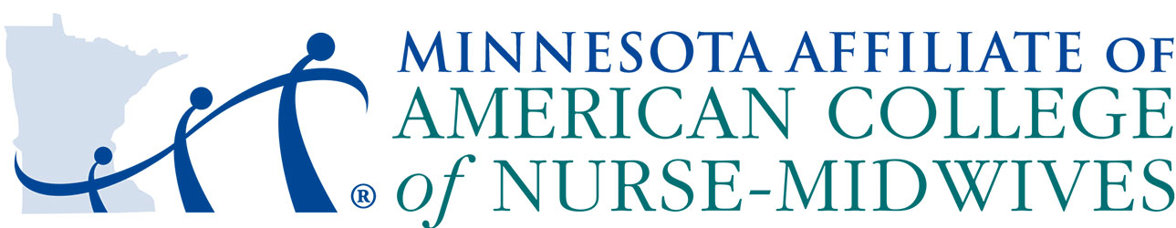

**Scholarship Application:** *Helping student and community-based midwives attend the 2025 ACNM Annual Meeting in Palm Springs, CA*

**Purpose**: This scholarship assists current nurse-midwife students AND community-based midwives, who are members of the MN Affiliate of ACNM, to attend the ACNM annual meeting, October 10-13. The scholarship award will be up to $1000 to cover hotel and travel expense reimbursement. Scholarship funds cannot be used for food and beverages.

**Available scholarships:** Up to 2 community-based midwives and up to 4 student nurse-midwives.

**Eligible Applicants**:

* A student currently enrolled in an accredited nurse-midwife program OR a nurse-midwife working at a community based clinic, birth-center, or home birth practice
* A student in good standing
* Current licensure as an RN, and licensure as midwife, if practicing
* Member of the Minnesota Affiliate of the ACNM

To apply, please submit the below application to [secretary.mnacnmaffiliate@gmail.com](mailto:secretary.mnacnmaffiliate@gmail.com)

**Applications are due by 2359 on Tuesday, July 1st**

**Recipients of the scholarship will be announced Monday July 14th**

NAME:

ADDRESS:

E-MAIL:

TELEPHONE #:

EDUCATION PROGRAM: ACNM MEMBERSHIP #:

Do you identify as LGBTQIA, Black, Indigenous, or Person of Color?

If chosen as a recipient, do you agree to stay on-site at the conference designated hotel?   
  
If chosen, do you agree to individually or in collaboration with other scholarship recipients, create a brief powerpoint summarizing your conference experiences and take-aways and present at the following MN ACNM Affiliate business meeting?

**Please draft a document (no more than 2 pages) that addresses the following**:

1. If you are a student midwife, please describe your progression in your educational program and anticipated graduation date. If you are a community-based midwife, please tell us about your practice.
2. Describe plans for your midwifery career.
3. Why do you want to attend the 67th Annual ACNM meeting and why you are the best candidate for this scholarship.